XcelRegister has been created to replace the existing register process for updating the following.

* Area Calc Checklist
* Field Data Register
* Survey Report Register
* TQ /RFI Register

Instructions

**SQL Server Setup**

XcelRegister has been designed to work with Microsoft’s SQL Server Express 2012. Therefore there will need to be one computer on the network that will have to act as the Server.

The Server must be powered on with MS SQL Server Express 2012 installed and running for any updates (create/modify) to be made to the register. Below is a link for the installer.

[Microsoft® SQL Server® 2012 Express](http://www.microsoft.com/en-au/download/details.aspx?id=29062)

Microsoft® SQL Server® 2012 Express is a powerful and reliable free data management system that delivers a rich and reliable data store for lightweight Web Sites and desktop applications.

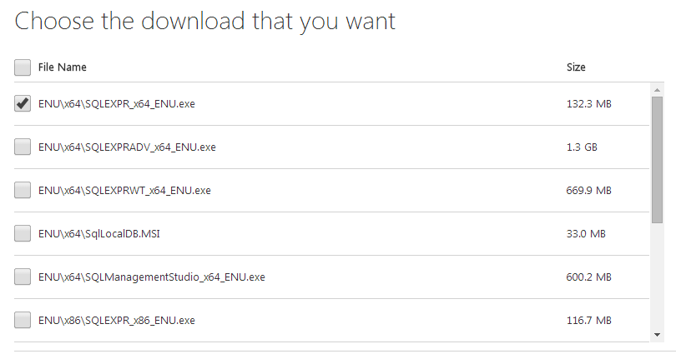

*Image: SQL Express Selected for download*

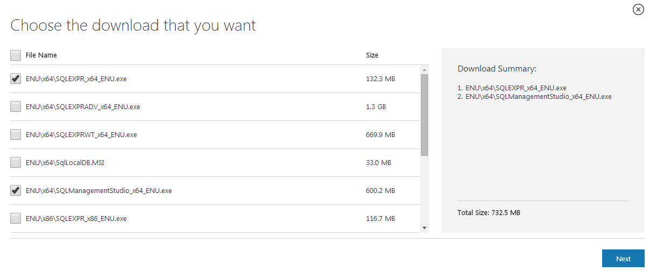*Image: SQL Express and the Management Studio Selected for download*

Installation of Microsoft SQL Server Express on Windows 7

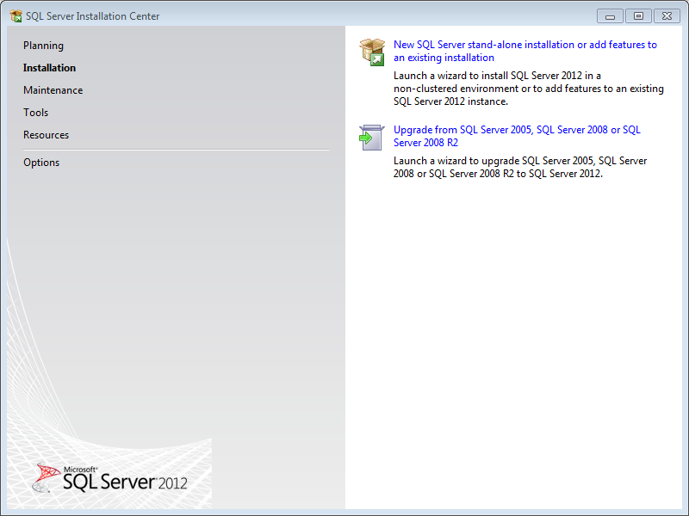

Select the **New SQL Server stand-alone installation**, unless you know you already have an older version of SQL running on the PC. Include server product updates when prompted.

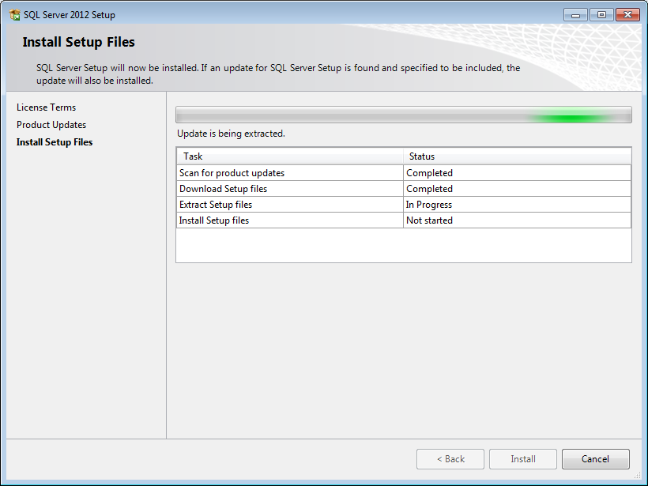

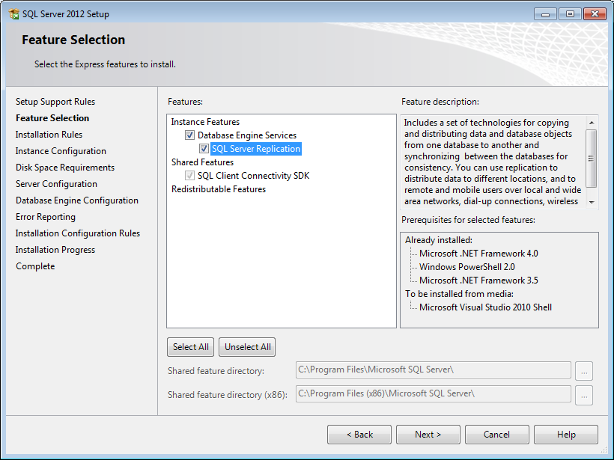

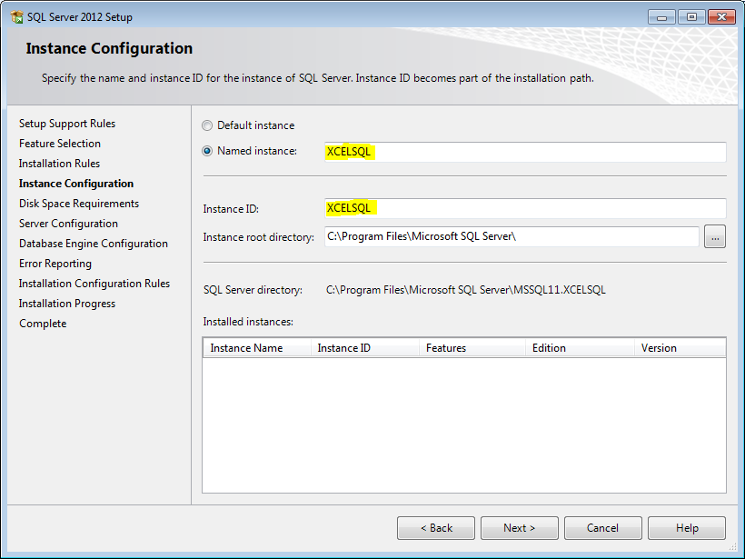

To avoid any chance of having duplicate SQL Server names on the network, change the default Named Instance ID to something original e.g. XCELSQL

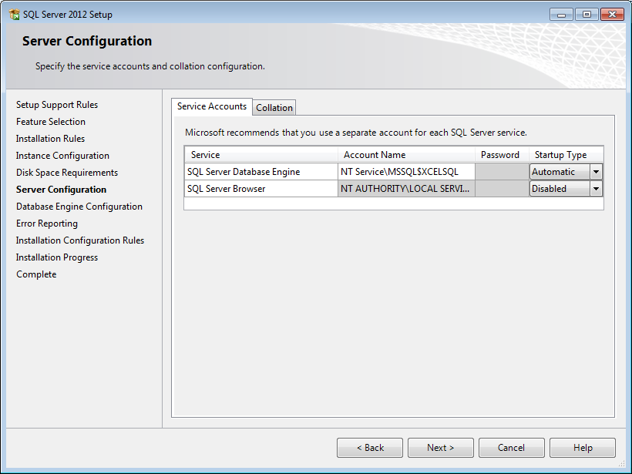

Leave the Server Configuration as Default Values.

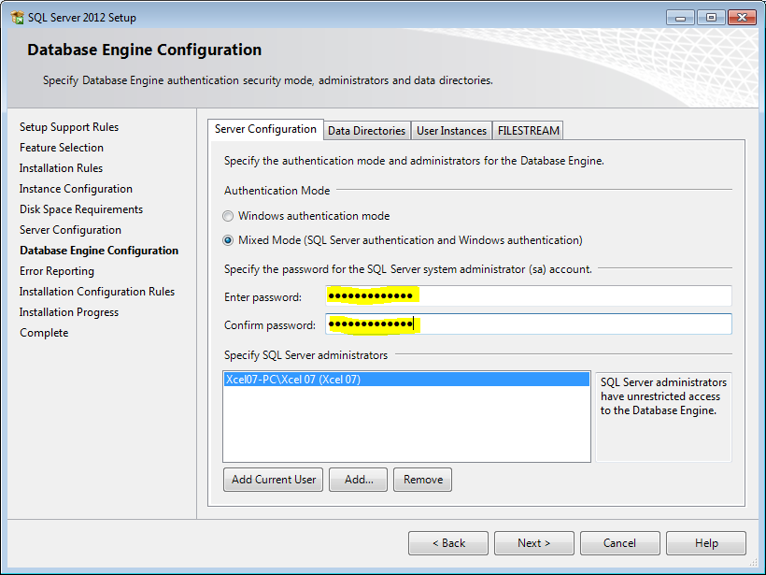

This step is **important**, The Button for **Mixed Mode** must be selected so the administrator account ‘sa’ for SQL can be active. This account will be used by the XcelRegister application to access the database.

**Set the password** to something like **XcelSurveying**. Don’t lose this password as it will be needed to used later.

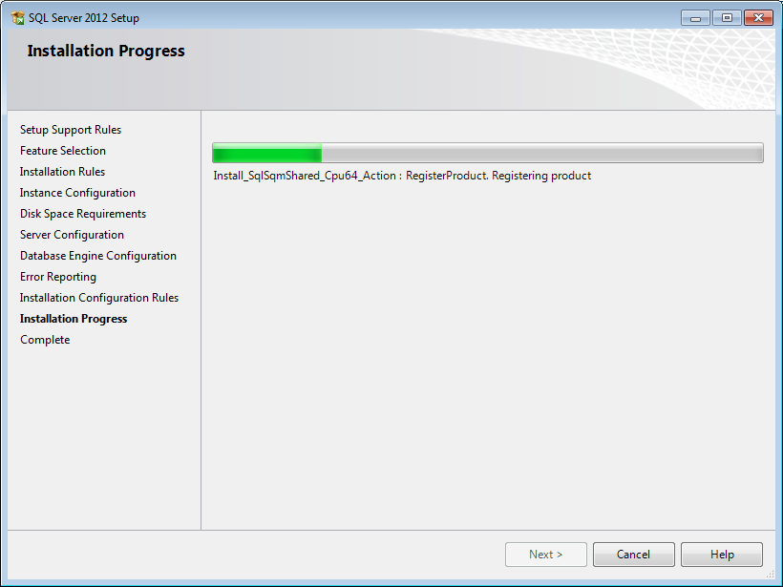

From here it will take a few minutes to finish the insall.

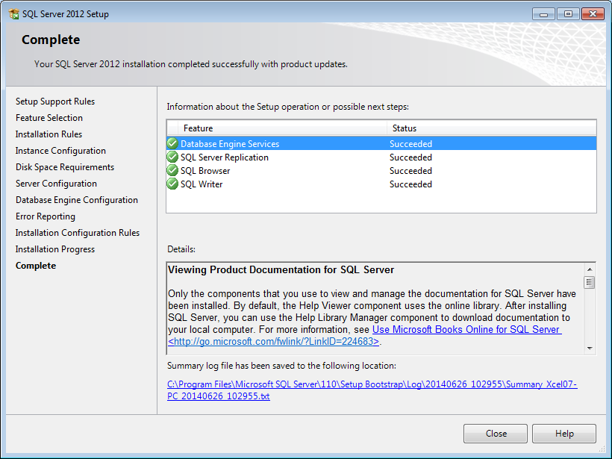

The Installation is now complete

Now the Management Studio needs to be installed to gather the server name

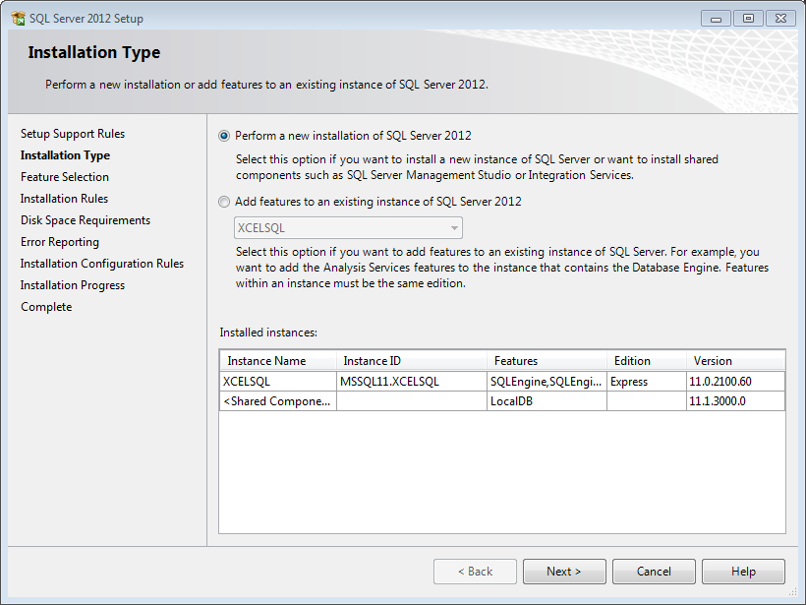

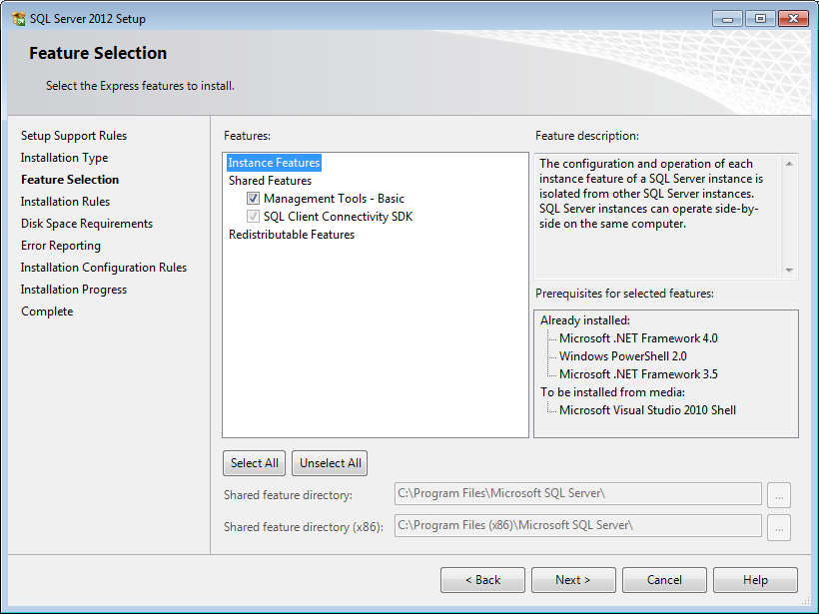

System.Data.SqlClient.SqlException (0x80131304): Cannot open database “register” requested by the login.